
Uxendon Manor Primary School
Safeguarding Information for Parents and Visitors.
‘Safeguarding and promoting the welfare of children is everyone’s responsibility. Everyone who comes into contact with children and their families has a role to play.’

If you have any concerns about the health and safety of a child at this school or feel that something may be troubling them, you should share this information with an appropriate member of staff straight away. If you think the matter is very serious and may be related to a child protection concern, you must talk to the people below immediately.

You might become involved because:
- You may see an injury for which there is no clear explanation.
- A child may want to tell you about something that is happening to them.
- Another person may express concerns about a child’s wellbeing.
- You may have noticed significant changes in the way a child behaves at school.
What to do:
- Listen without making judgement.
- Do not promise confidentiality.
- Reassure the child.
- Speak to Designated/Deputy Safeguarding Lead(s) as soon as possible.
- Be professional. Do not discuss the matter with anybody else.
Recognise, Report, Record:
- Avoid judgements and opinions.
- Seek advice for the school’s safeguarding leads as soon as possible.
- Record what the child said, using the child’s own words.
- Note the context.
- Even if you think something has already been reported, pass it on.
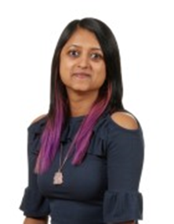


DSL
Mrs Devakumar
Inclusion Leader
Rainbow Room
(Ground Floor)
DDSL
Miss van der Sluys
Every Child Matters Leader
1VL
(Ground Floor)
DDSL
Miss Merlin
Assistant Inclusion Leader
2M
(Ground Floor)

Any allegation involving a member of staff, a child’s foster carer or a volunteer at the school must be reported directly to the Head, unless it involves the Head and then it should be reported directly to the Chair of the Governing Body.

Tel: 0208 907 5019 Email: inclusion@uxendonmanor.com or safeguarding@uxendonmanor.com
The Chair of the Governing Body: Ms Shekira Malcolm Tel: 07966 151536
Brent Family Front Door: 020 8937 4300
Thank you for supporting and safeguarding the children at our school.

